**Module 3: Docker Part 1**

**Assignment – 5**

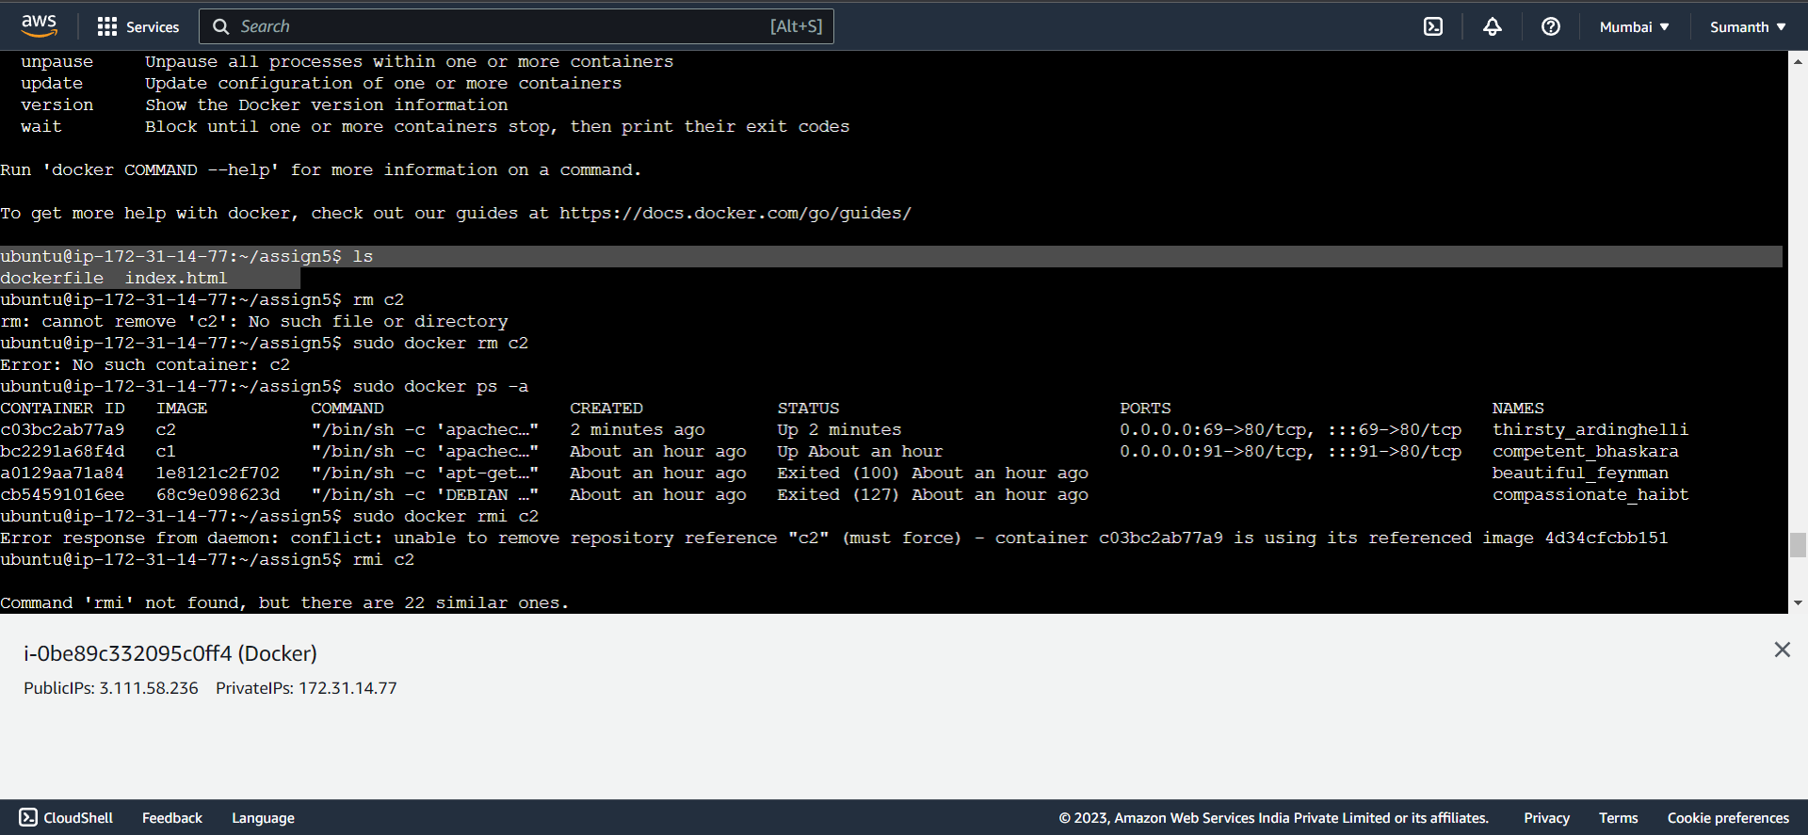

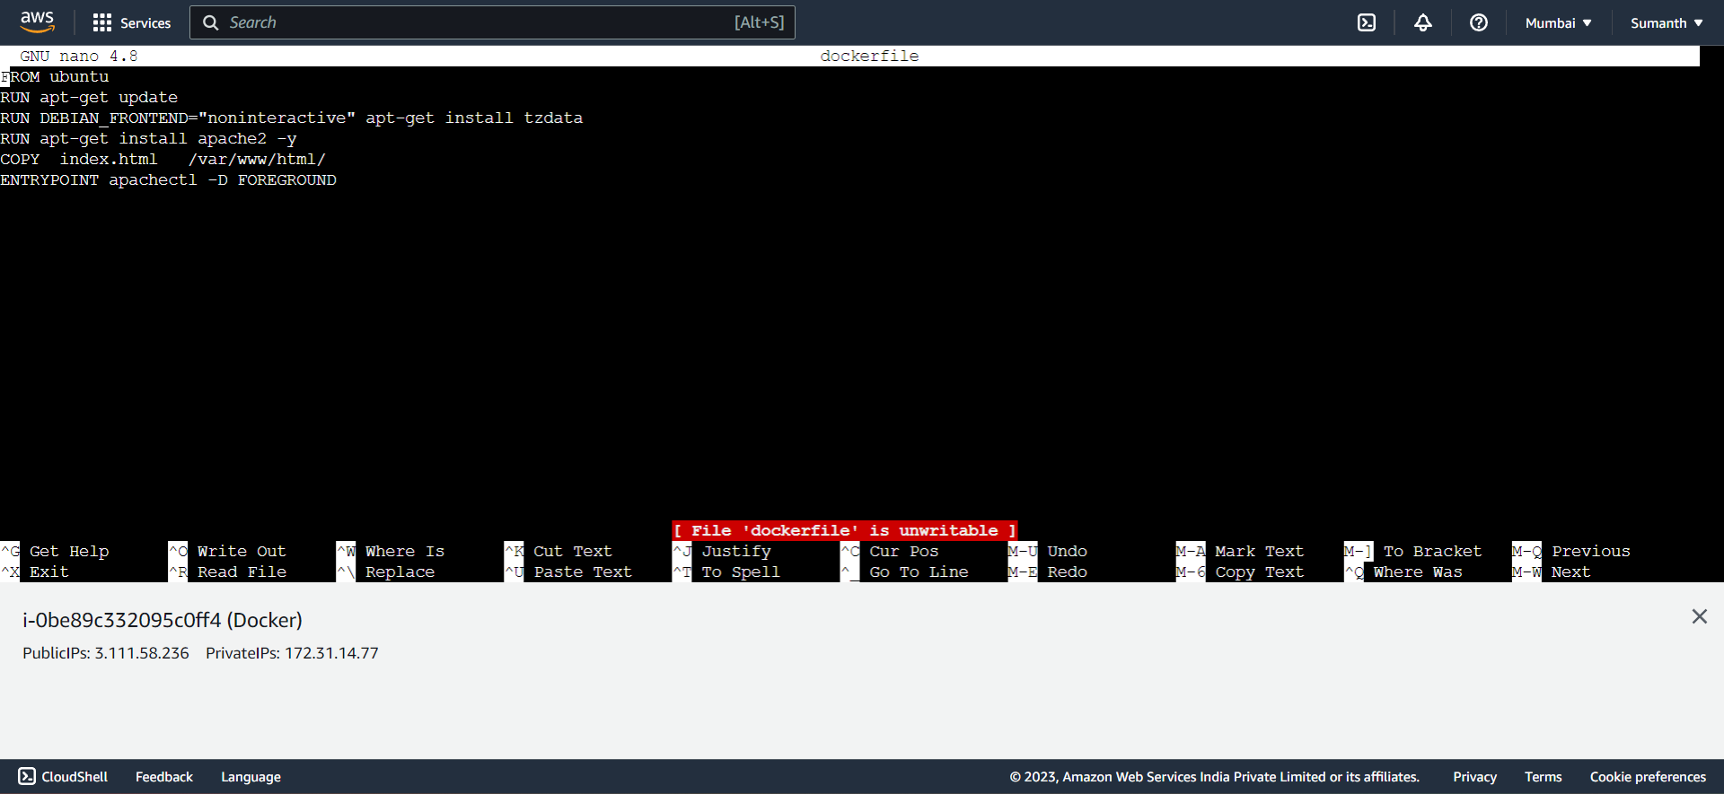

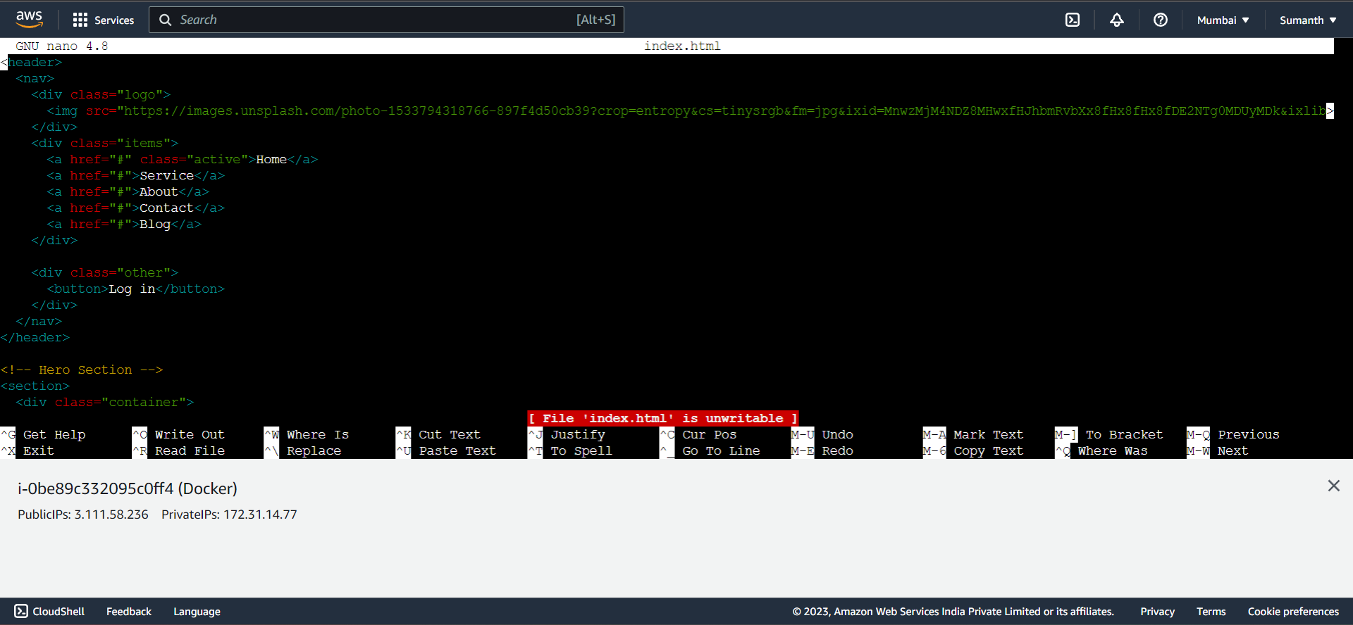

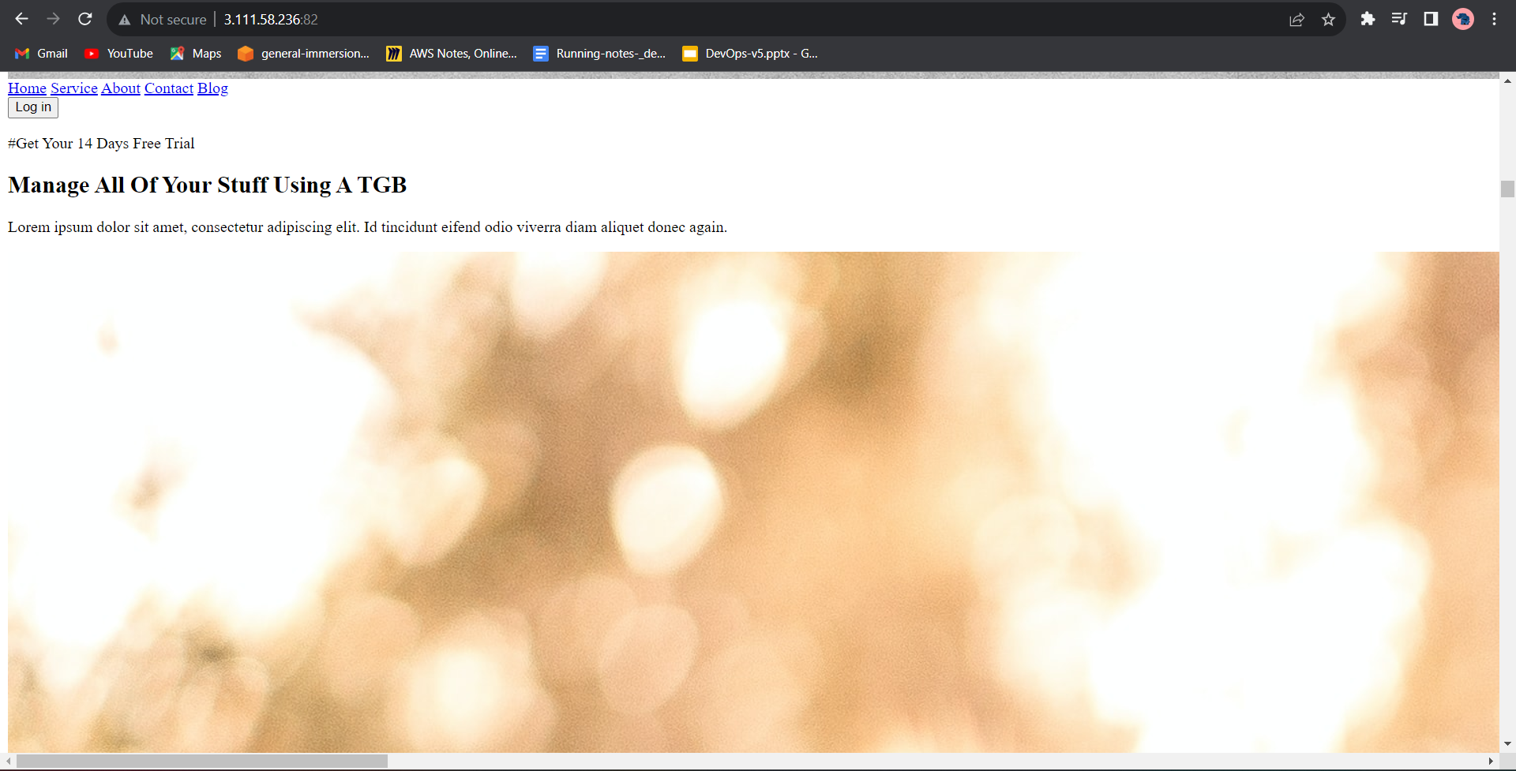

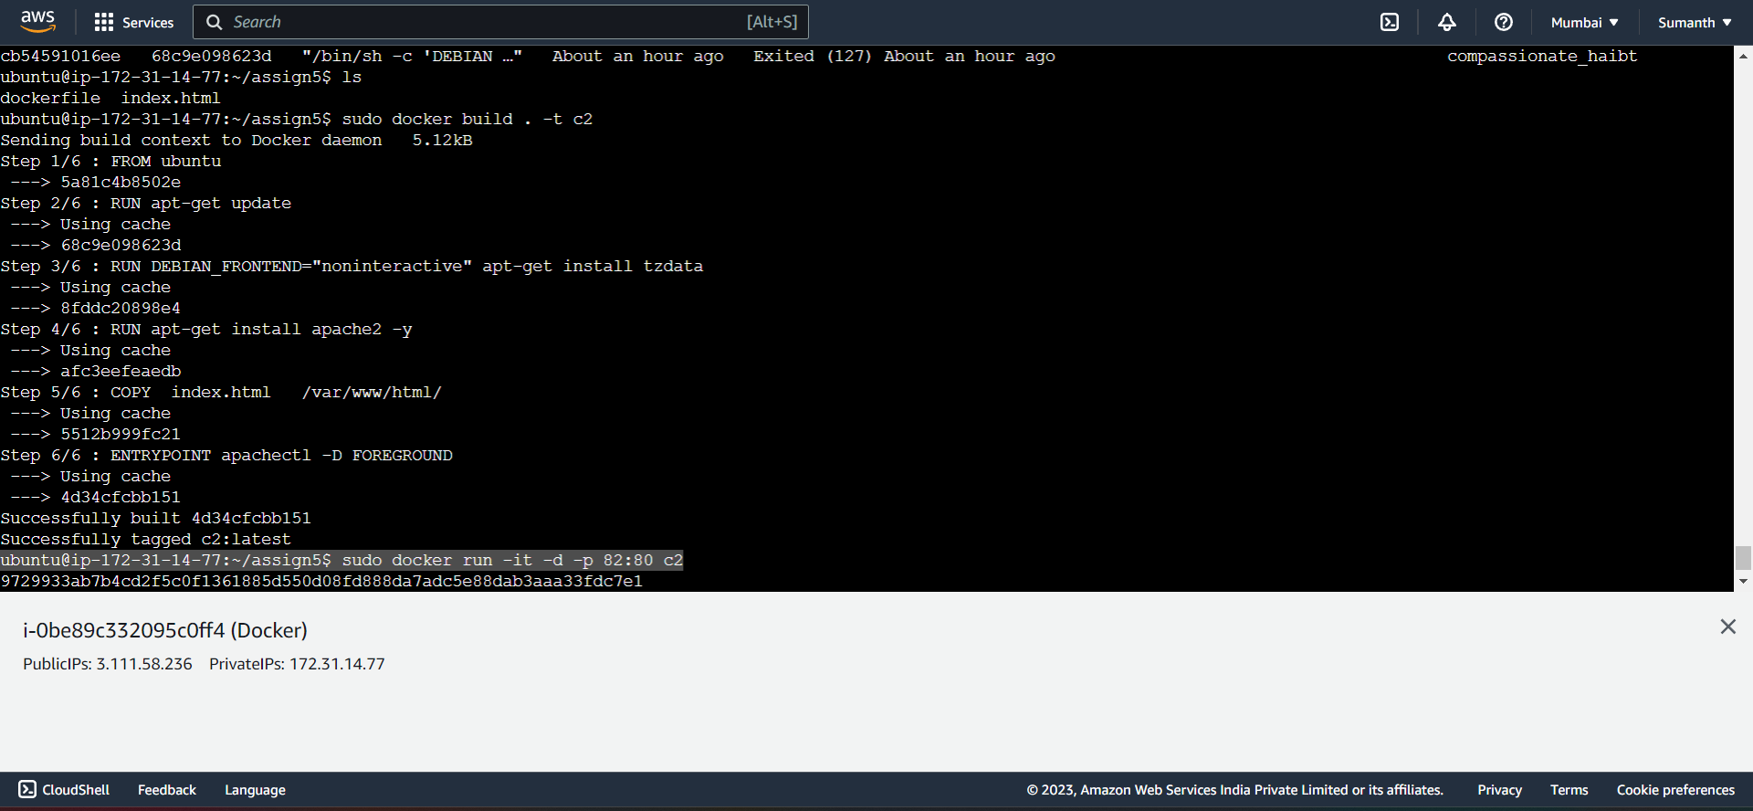

* Commands used for the assignment

24 sudo apt-get update

25 ls

26 mkdir assign5

27 ls

28 cd assign5

29 sudo nano dockerfile

30 sudo nano index.html

34 sudo docker build . -t c2

35 sudo docker images

51 sudo docker run -it -d -p 82:80 c2